📄 Test Case: TC59_InwardLodgeBill
❌ FAILED:
[2026-03-11 11:01:27] Bill ID - 003B0500_2025 Lodged successfully.
[2026-03-11 11:02:13] ? Login Failed: User is already logged in.
[2026-03-11 11:02:13] ? Assertion Failure: Finacle Login Error: User is already logged in.
↳ Reason: ❌ ❌ Assertion Failure: Finacle Login Error: User is already logged in.

📸 Screenshot:
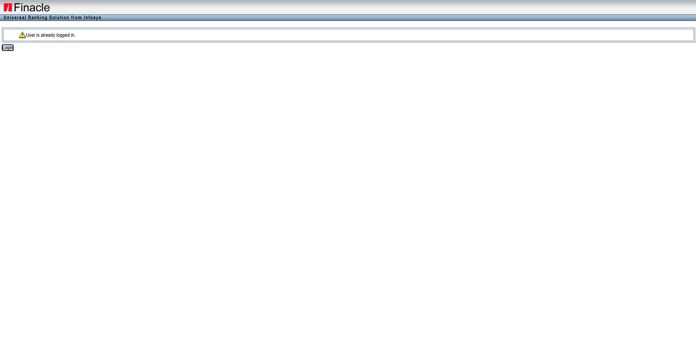
📄 Test Case: TC60_ModifyTheLodgeBillWhichIscreated
❌ FAILED:
[2026-03-11 11:03:52] ? Error: Tenor Details
[2026-03-11 11:03:52] ? Assertion Failure: Test failed: Tenor Details
↳ Reason: ❌ ❌ Assertion Failure: Test failed: Tenor Details

📸 Screenshot:
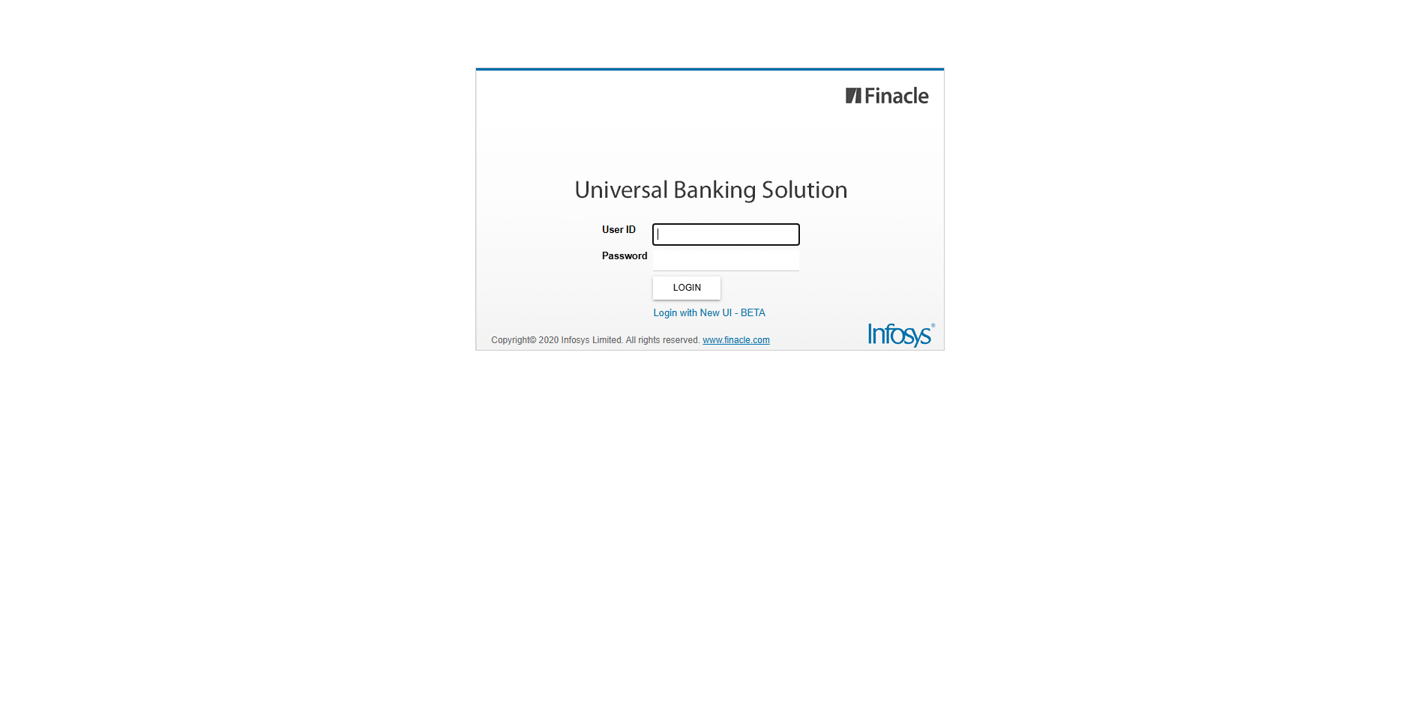
📄 Test Case: TC61_CanceltheModifiedInwardBill
❌ FAILED:
[2026-03-11 11:04:44] ?? Error displayed: E4221 - [Nothing to Cancel]
[2026-03-11 11:04:44] ? Assertion Failure: ? Unexpected error during Mark/Invoke: E4221 - [Nothing to Cancel]
↳ Reason: ❌ ❌ Assertion Failure: ❌ Unexpected error during Mark/Invoke: E4221 - [Nothing to Cancel]

📸 Screenshot:

📄 Test Case: TC62_AmendTheInwardBillWhichIsLodge
❌ FAILED:
[2026-03-11 11:05:52] errorMsg = C22 - The previous process is not yet verified.
[2026-03-11 11:05:52] LabelText: null
[2026-03-11 11:05:52] BillID: null
[2026-03-11 11:05:52] ? Error: C22 - The previous process is not yet verified.
[2026-03-11 11:05:52] ? Assertion Failure: Test failed: C22 - The previous process is not yet verified.
↳ Reason: ❌ ❌ Assertion Failure: Test failed: C22 - The previous process is not yet verified.

📸 Screenshot:

📄 Test Case: TC63_DishonorOfInwardBillWhichIsAmended
❌ FAILED:
[2026-03-11 11:06:51] ? Error: E4221 - The bill ID cannot be dishonored. Bill Status: [Delinked]
[2026-03-11 11:06:51] ? Assertion Failure: Test failed: E4221 - The bill ID cannot be dishonored. Bill Status: [Delinked]
↳ Reason: ❌ ❌ Assertion Failure: Test failed: E4221 - The bill ID cannot be dishonored. Bill Status: [Delinked]

📸 Screenshot:

📄 Test Case: TC64_InquireTheInwardBill
❌ FAILED:
[2026-03-11 11:08:05] ? Assertion Failure: Exception occurred: Expected condition failed: waiting for presence of element located by: By.xpath: //td[contains(normalize-space(text()),'Bill Type')]/following-sibling::td[@class='textfielddisplaylabel'] (tried for 10 second(s) with 500 milliseconds interval)
↳ Reason: ❌ Exception occurred: Expected condition failed: waiting for presence of element located by: By.xpath: //td[contains(normalize-space(text()),'Bill Type')]/following-sibling::td[@class='textfielddisplaylabel'] (tried for 10 second(s) with 500 milliseconds interval)

📸 Screenshot:
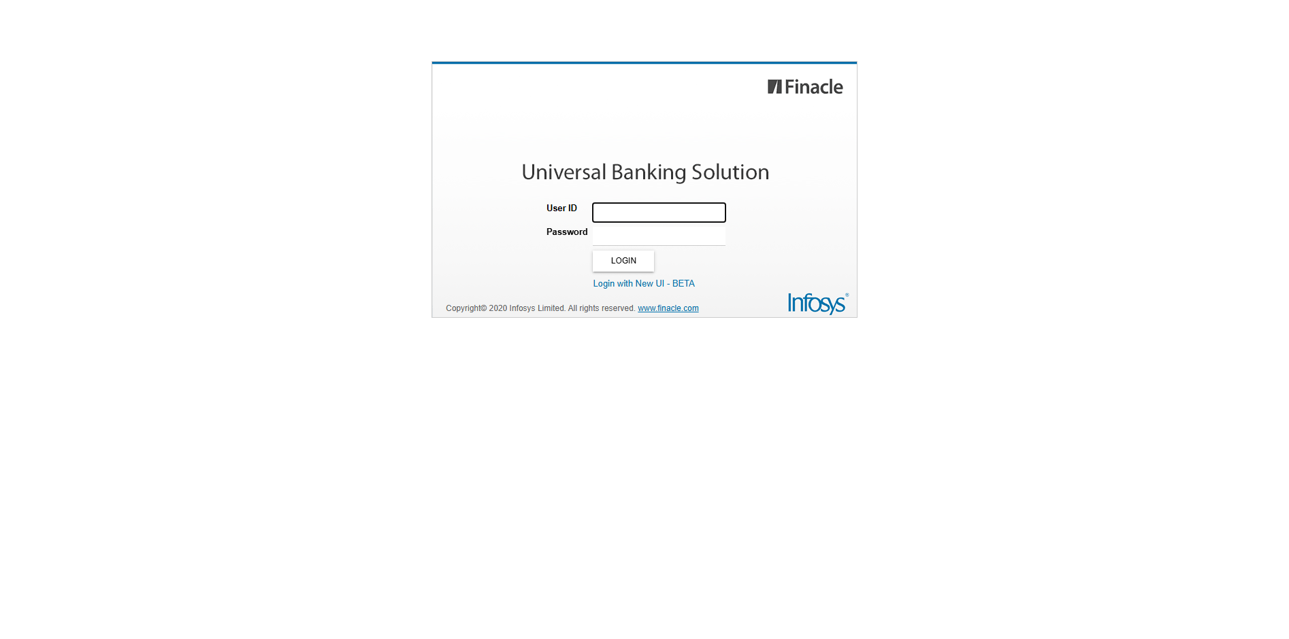
📄 Test Case: TC65_ProtestTheInwardBillWhichIsDishonoured
❌ FAILED:
[2026-03-11 11:10:16] ? Error: E4221 - Liablity Exists, Recovery Event should be performed before Protest.
[2026-03-11 11:10:17] ? Assertion Failure: Test failed: E4221 - Liablity Exists, Recovery Event should be performed before Protest.
↳ Reason: ❌ ❌ Assertion Failure: Test failed: E4221 - Liablity Exists, Recovery Event should be performed before Protest.

📸 Screenshot:

============================================================
📊 Suite Summary: MIIBTests
===============================================
MIIBTests
Total tests run: 7, Passes: 0, Failures: 7, Skips: 0
===============================================
⏱️ Total Duration: 10 min 08 sec

